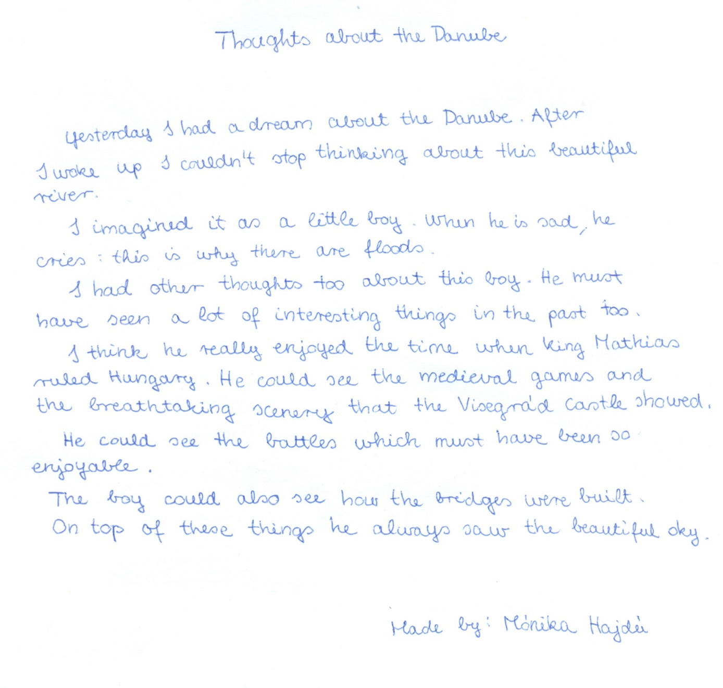

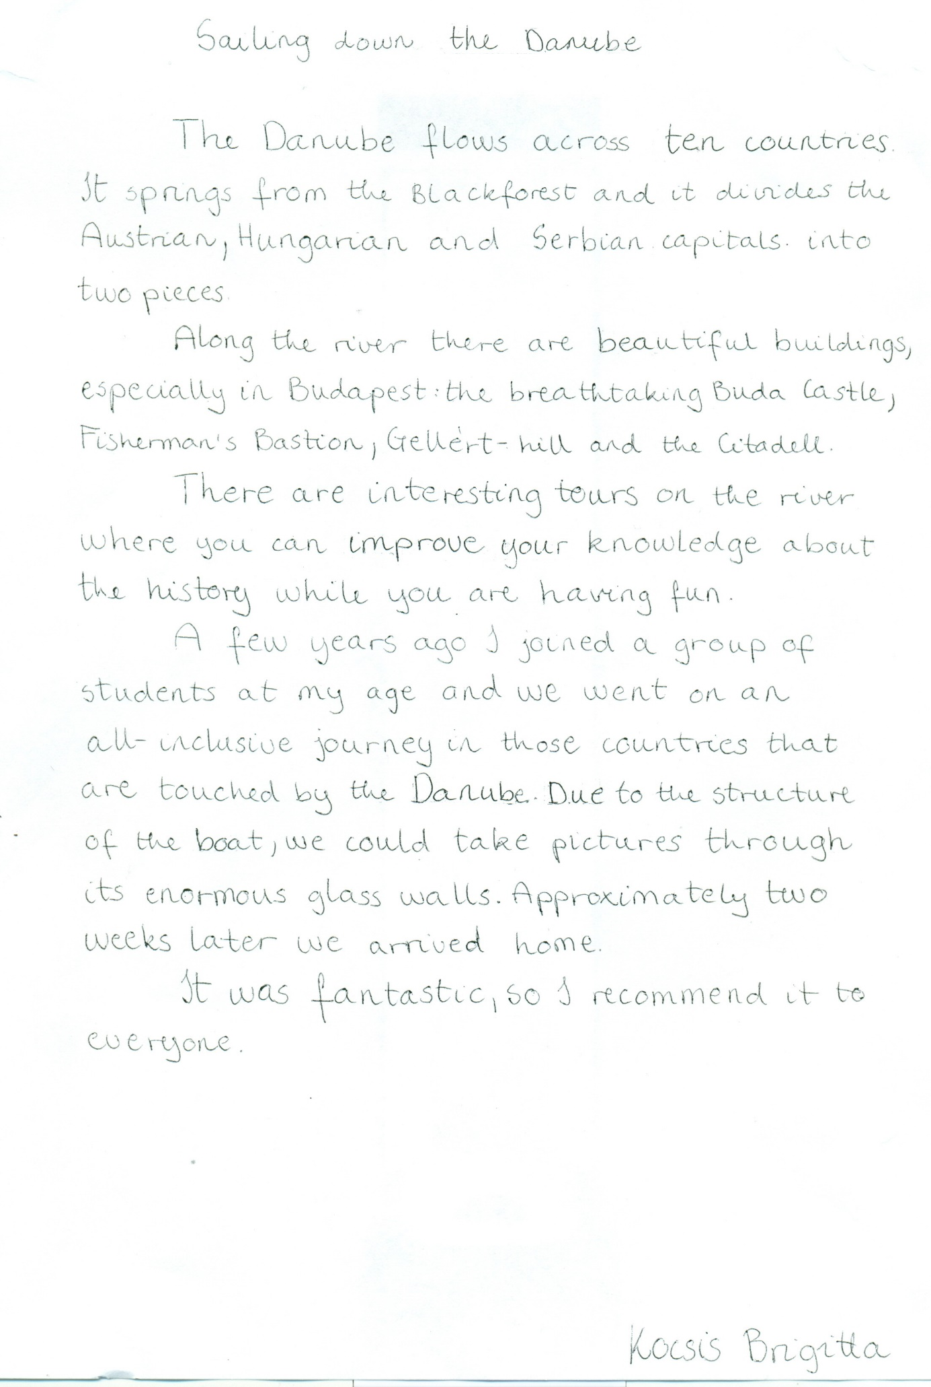

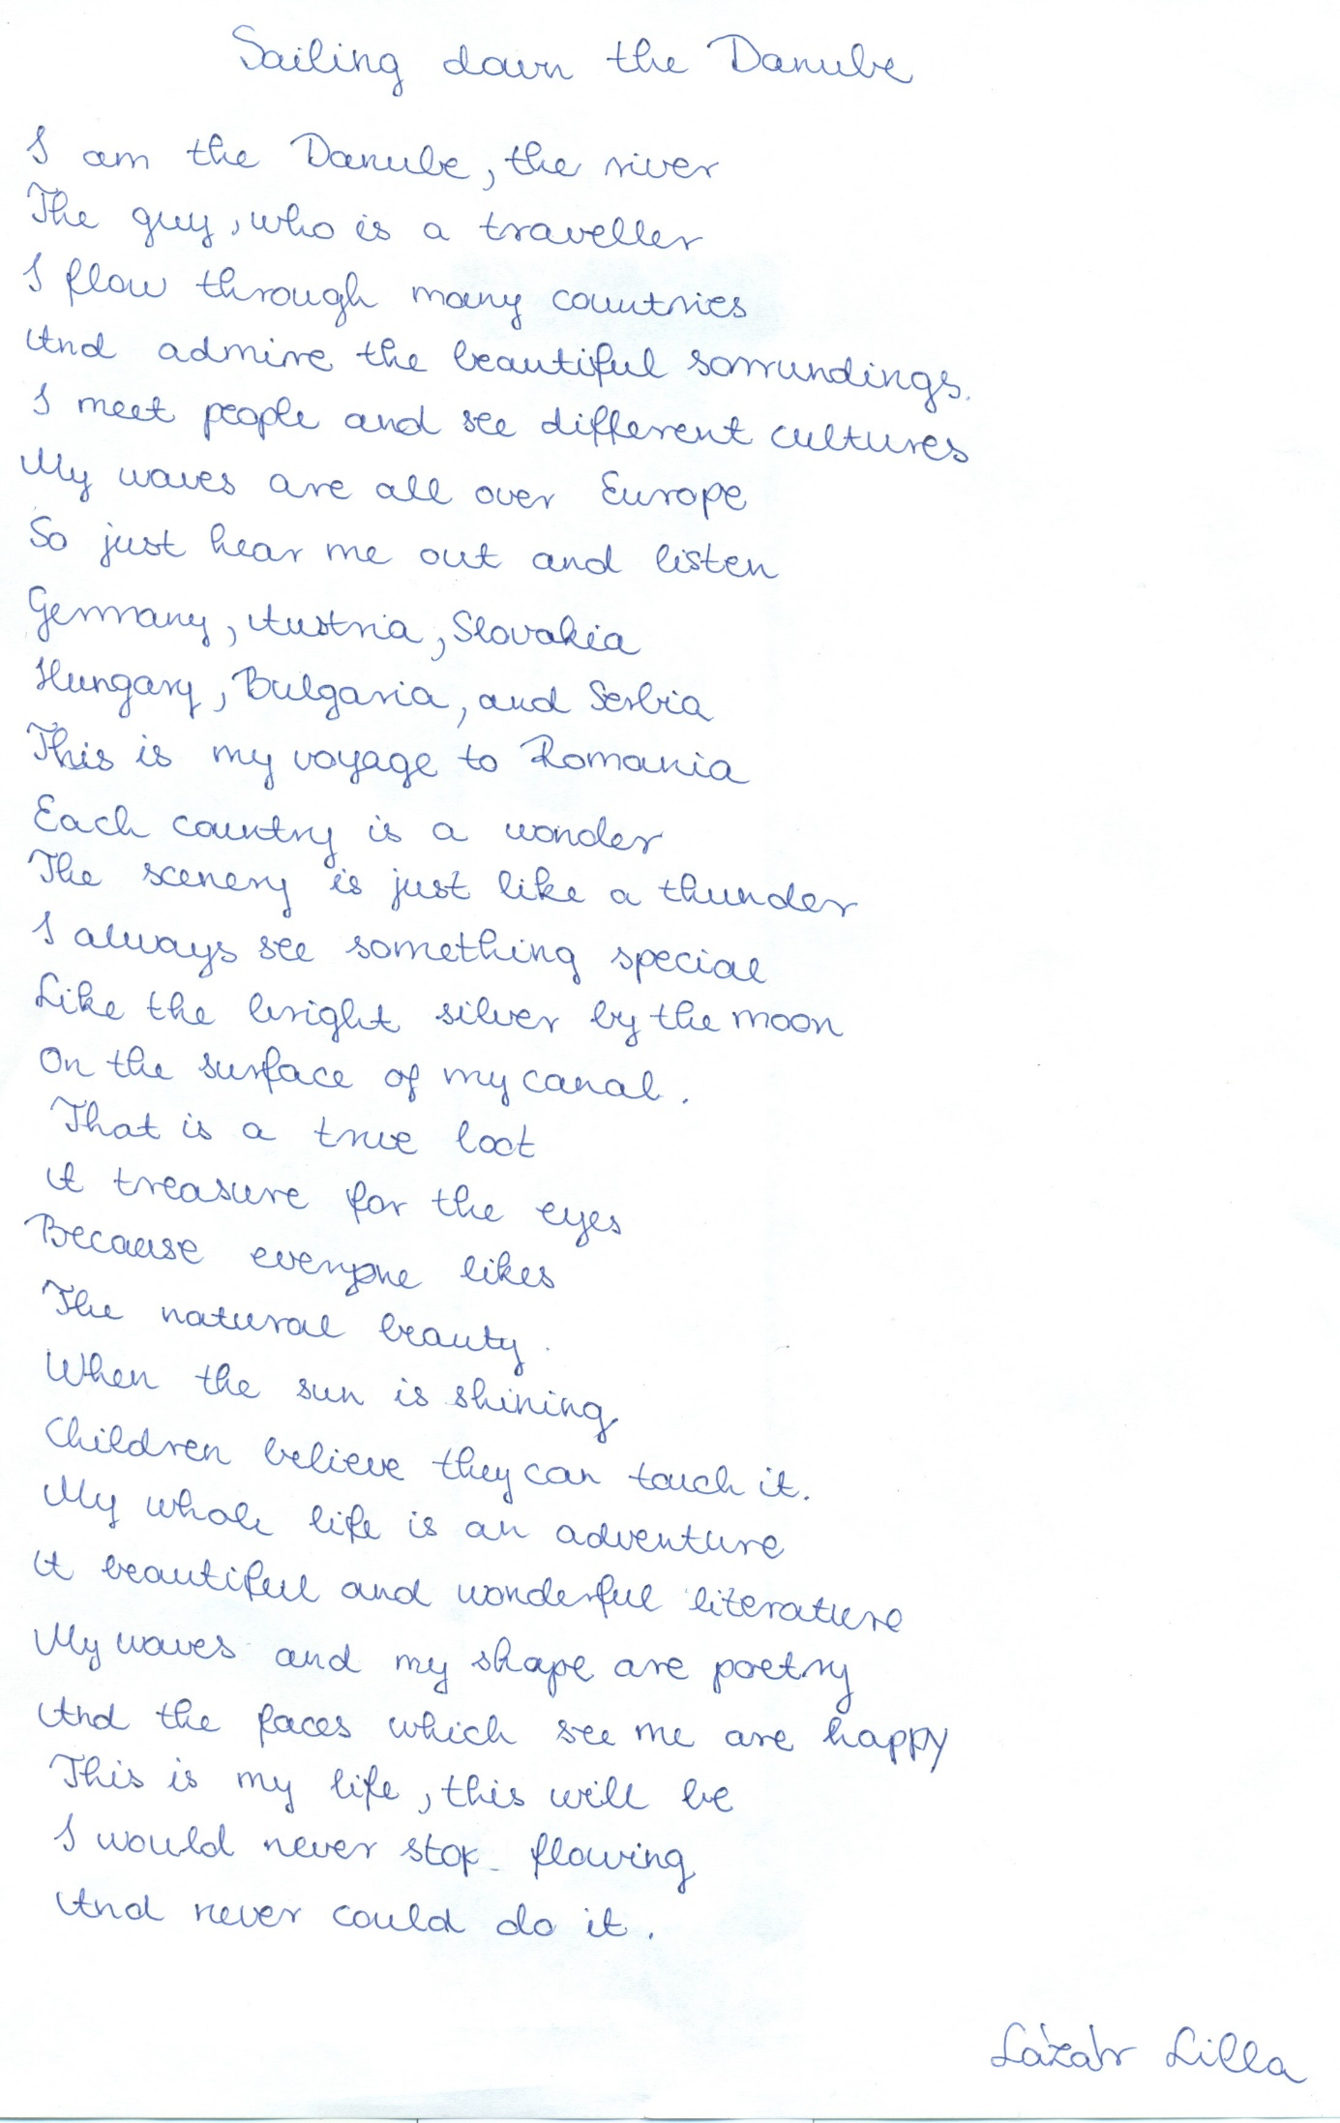

Sailing Down the Danube

Sailing down the Danube

through the big river

Sitting in the boat

my thoughts are getting deaper

The sun is going down

behind the Petőfi bridge

It’s so beautiful

like a heavenly image

The moon is coming up

over the Parliament’s dome

I’m just sitting in the boat

watching as the stars drown.

Korda Borbála